**D-Health App: Report 2**

Bar plot representing number of devices classified under each medical description classification

**Api call used: “**https://api.fda.gov/device/classification.json?count=medical_specialty_description.exact”

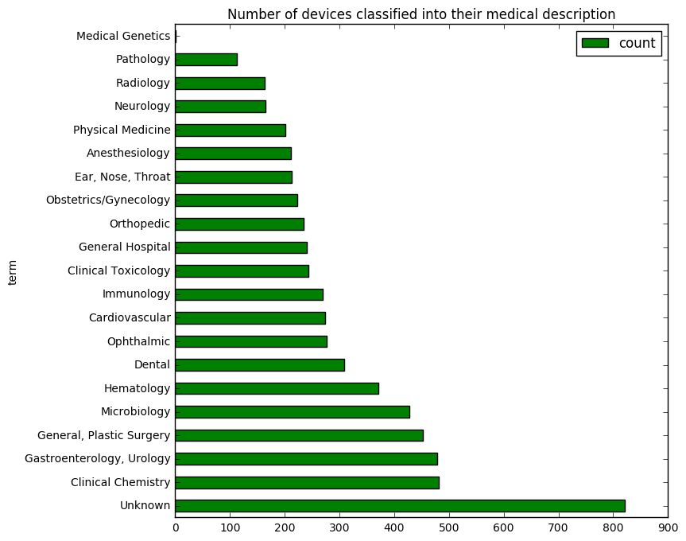

Pie chart representing the distribution of class (I, II, III) devices across the Ophthalmic devices

**Api call used:** “https://api.fda.gov/device/classification.json?search=medical_specialty_description=%22ophthalmic%22&count=device_class”

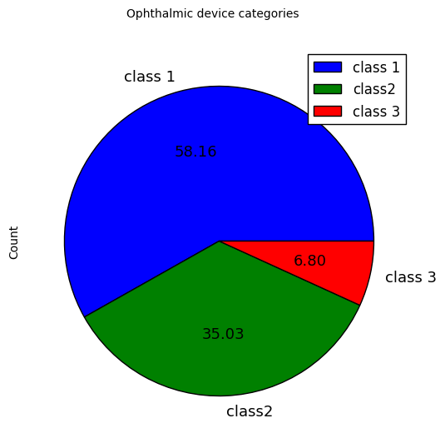

Pie chart representing the distribution of ophthalmic devices that are implants and not implants

**API call used:** https://api.fda.gov/device/classification.json?search=medical_specialty_description=%22ophthalmic%22&count=implant_flag

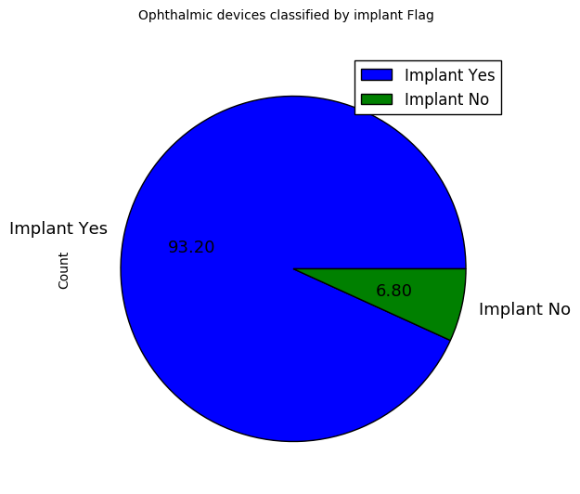

Bar chart representing the number of devices that are considered implants and not implants for each class of ophthalmic devices

**Api call used:**

https://api.fda.gov/device/classification.json?search=medical_specialty_description:"ophthalmic"+AND+implant_flag:"N"&count=device_class

